Skill 4 & 5

2520030034
P. Pratik Kumar

1. Create Database and Collections
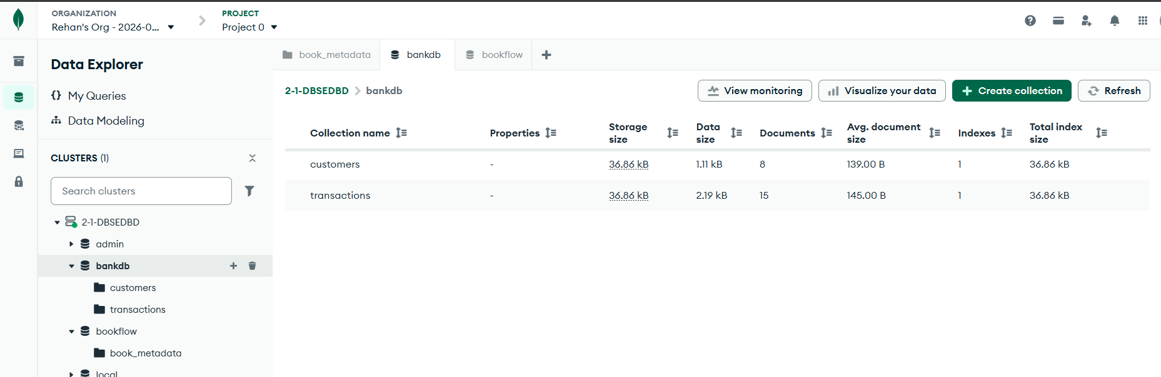

2. Insert Data into Customers
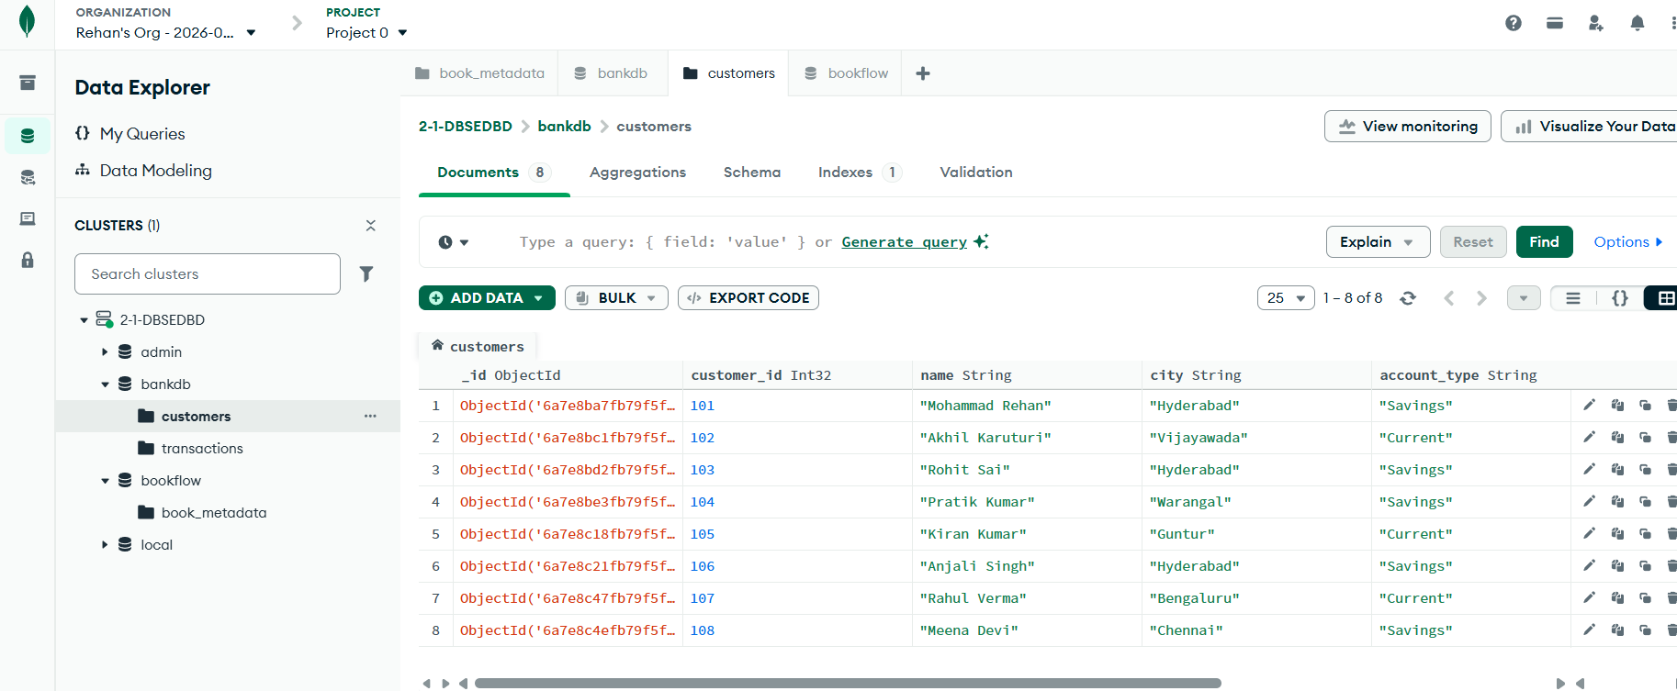

3. Insert Data into Transactions
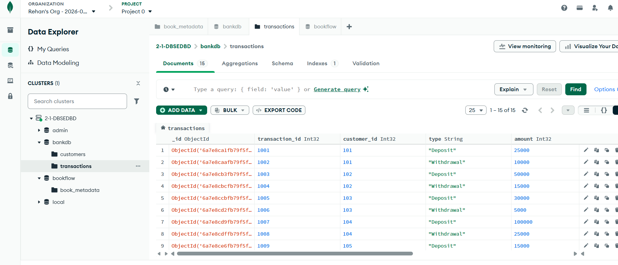

4. Find Active Users
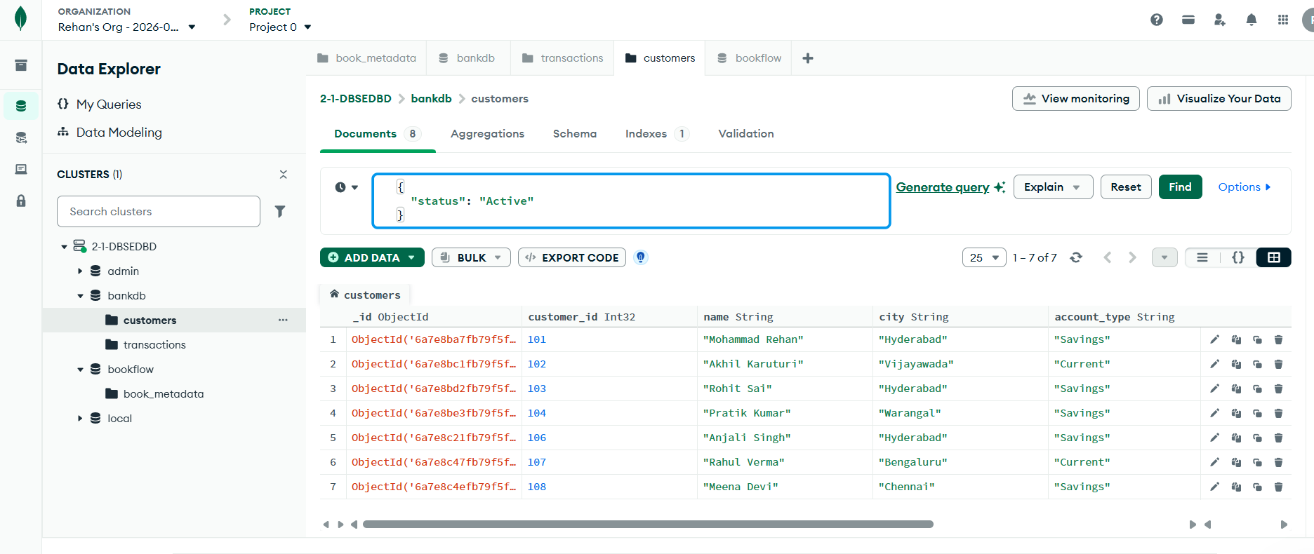

5. Find Customers With Balance Greater Than 100000
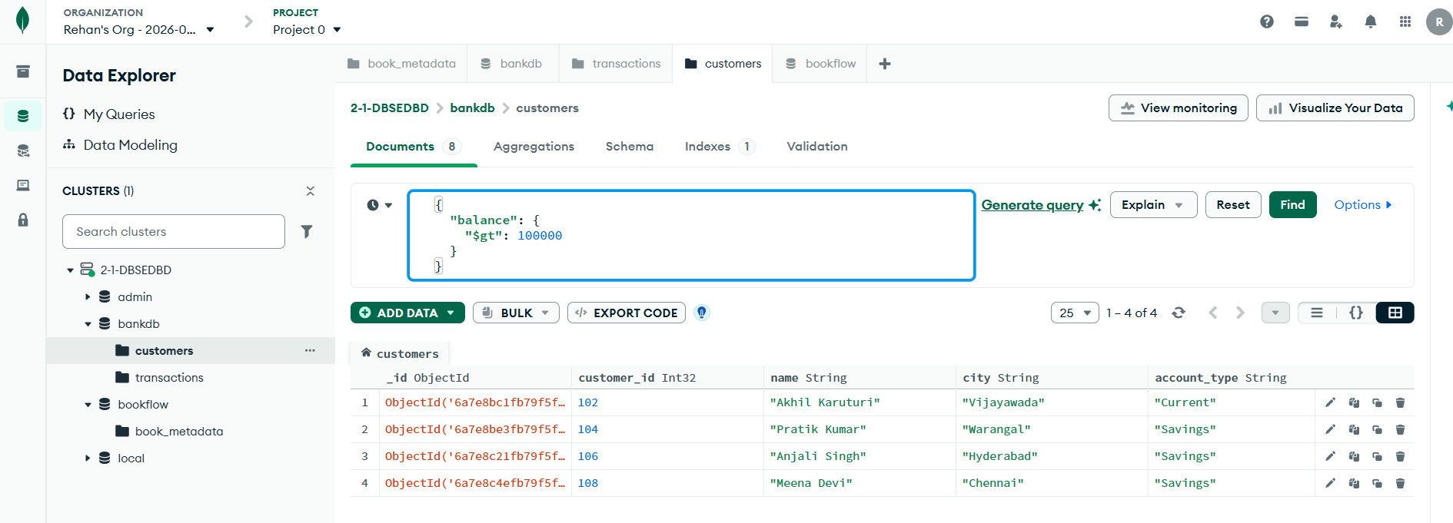
6. Find Hyderabad Customers
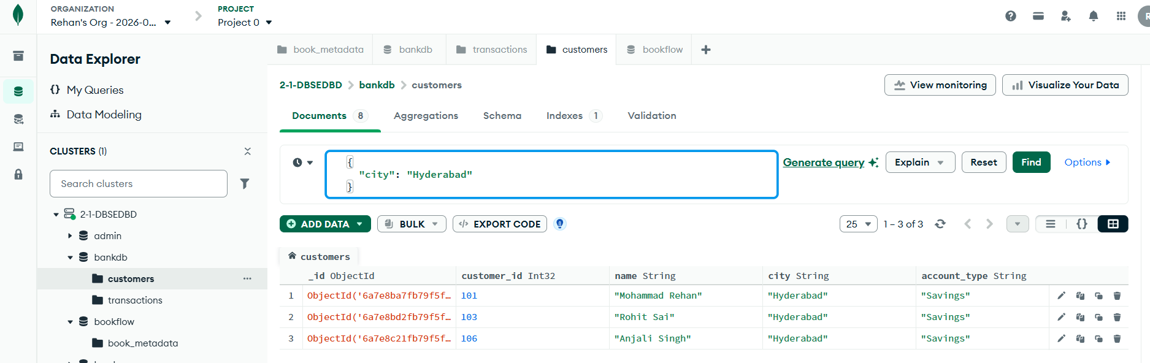
7. Find Savings Account Customers
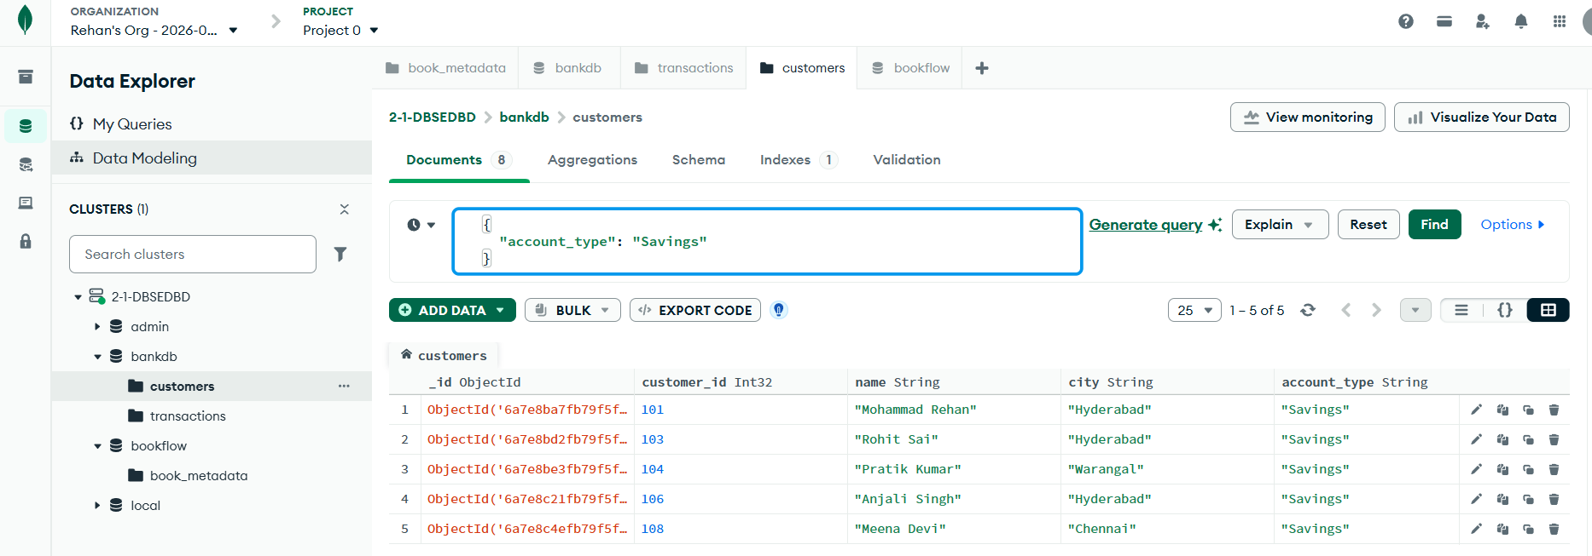

8. Find ATM Transactions
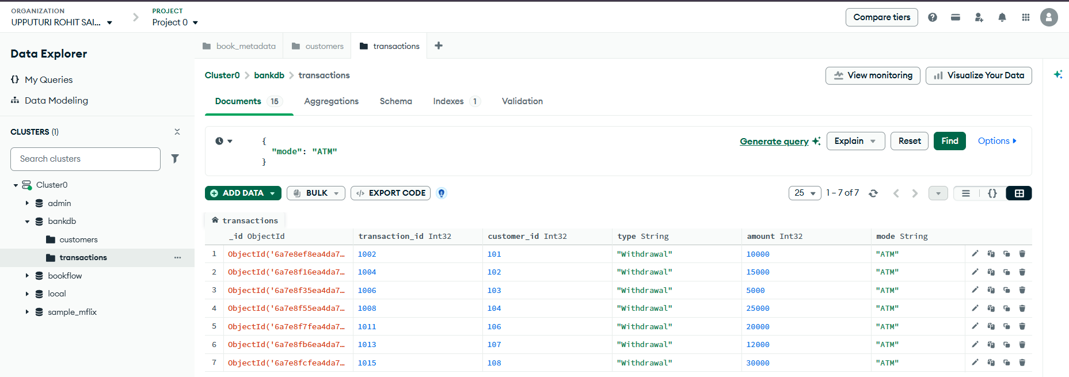

9. Find Deposits Greater Than 50000
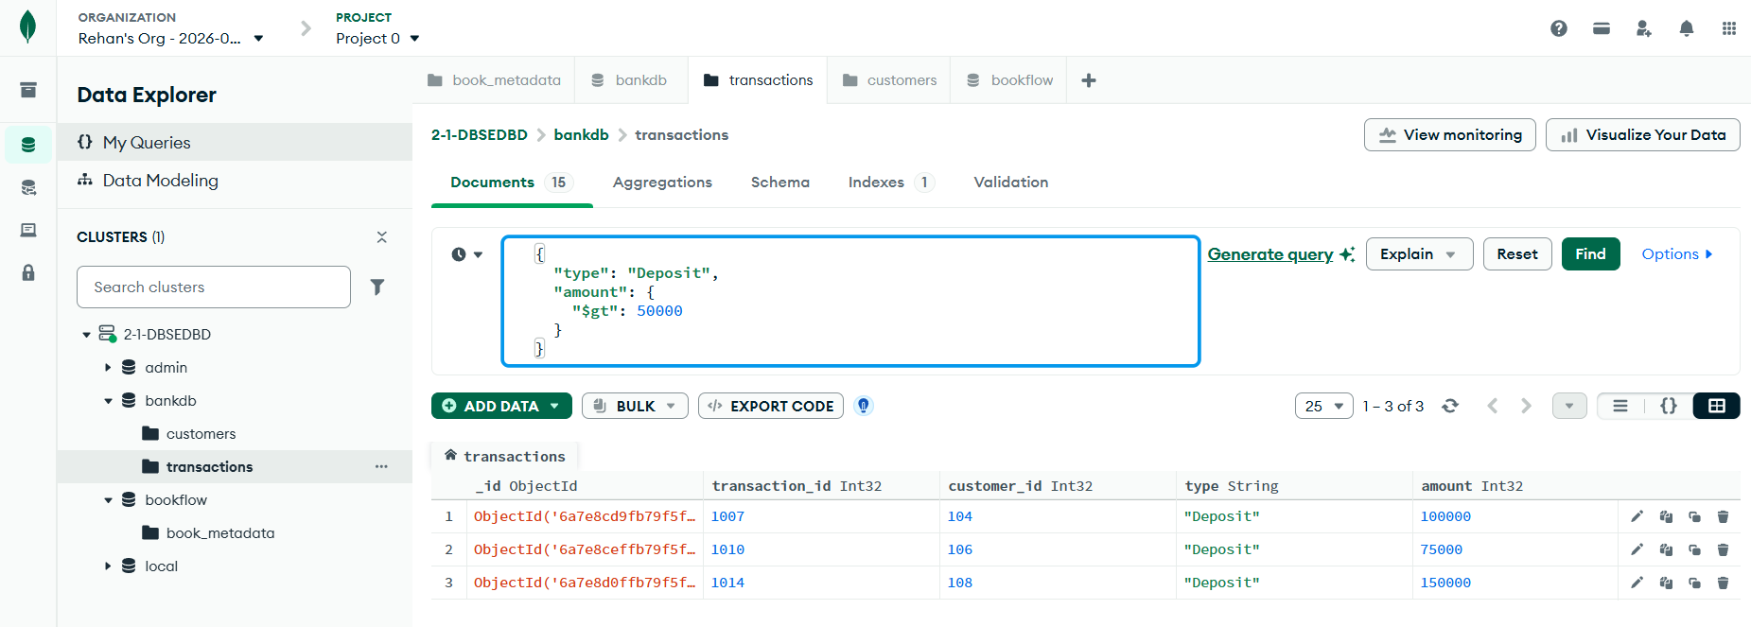
10. Find Hyderabad Customers With High Balance
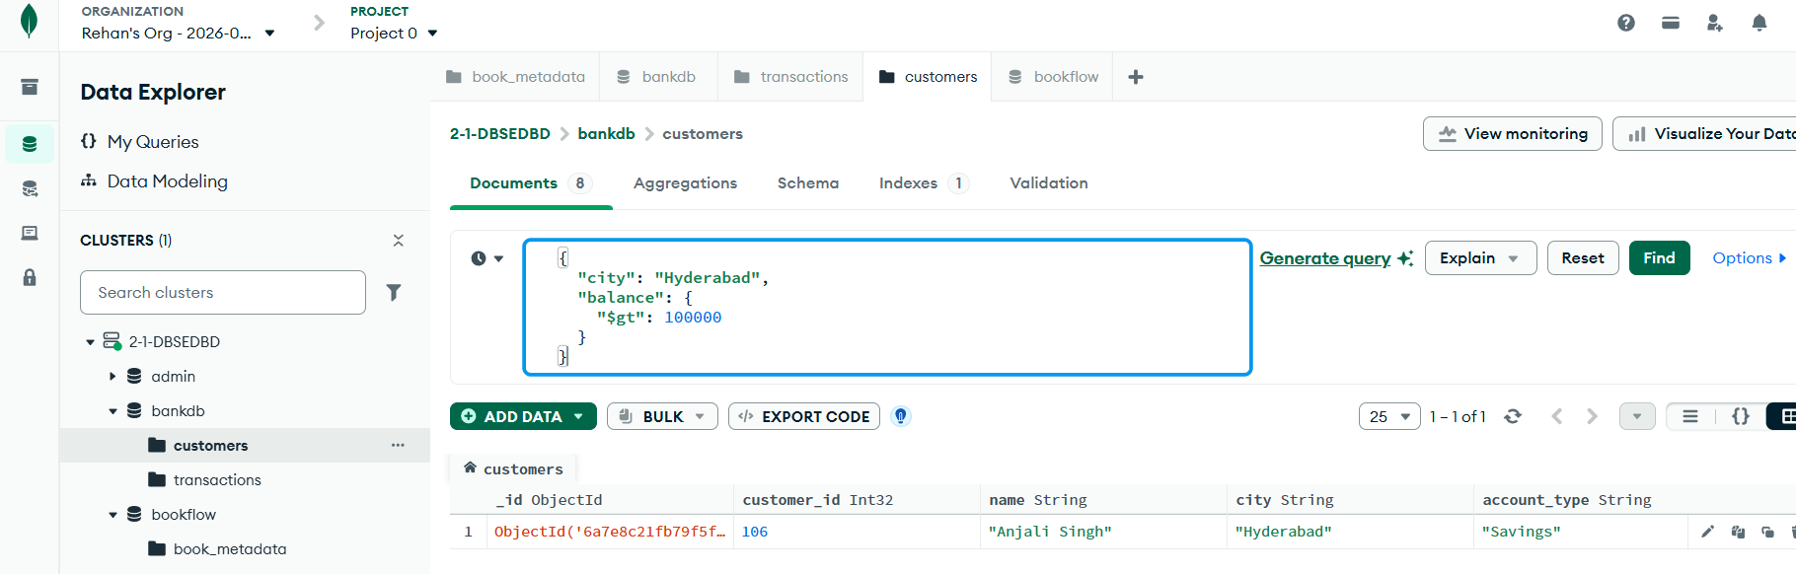

11. Sort Customers by Balance
